In this assignment, we want to establish **bounds** on the size of **optimal edit metric** **error-correcting codes** using a chosen computational approach.

**We want to show that a (n, d) q code with more than M codewords cannot exist, for some chosen values n, M, d, and q (by an exhaustive search for such a code)**

Assumptions:

* We will work with **fixed-length** (n, M, d) q​ **edit metric codes**.
* These are sets of M q-ary codewords of length n where every pair of codewords is at least d edit distance apart.
* We want to determine the largest possible value of M for a given n, d, and q such that there exists an (n, M, d) q code.

We start with the **simplest possible** (maybe the worst in terms of computational time ☹) approach and then try to improve it step by step. For the simplest approach to solve this problem, we can:

1. Generate all possible q-ary codewords of length n
2. Create all possible combination sets of those codewords
3. Check whether all pairs of codewords in each set have an edit distance >= d and if they do, they are valid.
4. Keep the valid set with the greatest number of codewords as an optimal edit metric error-correcting code with M codewords.

In the **simplest.py** file, you will find my code following the above steps as below:

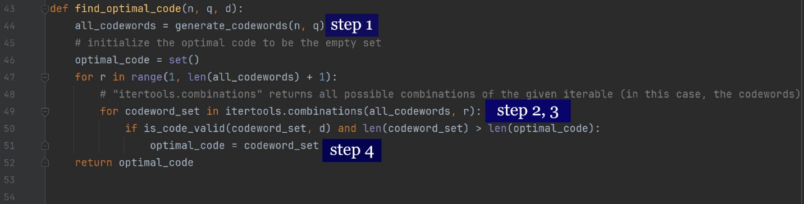

Notes:

* The “generate_codewords” function generates all possible q-ary codewords of length n
* The “is_code_valid” function checks whether the given code is a valid code with minimum edit distance >= d between any two codewords. For that purpose, it uses the “calculate_edit_distance” function implementing the algorithm in *slide 13- week7* and using a [*dynamic programming technique*](https://www.youtube.com/watch?v=We3YDTzNXEk).

**Analysis of the simplest approach**

The “find_optimal_code” function finds the optimal code of length n and size q with minimum edit distance d between any two codewords by exhaustively checking all the possible sets of codewords.

In this approach, we must check the space of $2^{(q^{n})}$ sets of codewords. (where $q^{n}$ is the number of possible codewords and in that case, we have $2^{(q^{n})}$ subsets )

For each set, we need to check the edit distance between every pair of codewords. In the worst case, this is $\left({P \atop 2}\right)$ comparisons per set, where M is the maximum number of codewords in a set.

Each comparison takes O(m * n) time, where m is the length of codeword1 and n is the length of codeword2. (In our assumptions we know that we are working on **fixed-length** (n, M, d) q​ **edit metric codes**. So, we can say each comparison takes O(n2) time)

As a result, the total time complexity is O( * * n2) which obviously needs improvements. Let’s see how far we can go with this approach and find the optimal codes with different parameters.

**q = 2**

|  |  |  |  |  |  |
| --- | --- | --- | --- | --- | --- |
| N \ d | 1 | 2 | 3 | 4 | 5 |
| 1 | 2 | 1 | 1 | 1 | 1 |
| 2 | 4 | 2 | 1 | 1 | 1 |
| 3 | 8 | 4 | 2 | 1 | 1 |
| 4 | 16 | 8 | 2 | 2 | 1 |
| 5 | **?** | **?** | **?** | **?** | **?** |

* + - For n = 4, d = 1 it took about a second
    - For n = 4, d = 2 it took 1.36s
    - For n = 5, d = 1 it took too much time :(

**q = 3**

|  |  |  |  |  |  |
| --- | --- | --- | --- | --- | --- |
| N \ d | 1 | 2 | 3 | 4 | 5 |
| 1 | 3 | 1 | 1 | 1 | 1 |
| 2 | 9 | 3 | 1 | 1 | 1 |
| 3 | **?** | **?** | **?** | **?** | **?** |

* + - For n = 2, d = 1 it took 0.02s
    - For n = 3, d = 1 it took too much time :(

**q = 4**

|  |  |  |  |  |  |
| --- | --- | --- | --- | --- | --- |
| N \ d | 1 | 2 | 3 | 4 | 5 |
| 1 | 4 | 1 | 1 | 1 | 1 |
| 2 | 16 | 4 | 1 | 1 | 1 |
| 3 | **?** | **?** | **?** | **?** | **?** |

* + - For n = 2, d = 1 it took 10.71s
    - For n = 2, d = 2 it took 0.5s
    - For n = 3 it took too much time :(

**Conclusion:** It is obvious that we cannot go beyond n = 4 or n = 5 in a reasonable amount of time. So, we start improving our approach.

To improve our approach, we can use **the backtracking algorithm** introduced in *week5slides*. Backtracking is a more efficient approach compared to a simple exhaustive search. By using backtracking, we can eliminate large portions of the search space that cannot possibly contain a solution, thereby reducing computation time significantly.